Experiment No.10: Design and implement asynchronous counter using decade counter IC to count up from 0 to n (n≤9) and demonstrate on seven segment display (using IC-7447).

Description:

Asynchronous counter is a counter in which the clock signal is connected to the clock input of only first stage flip flop. The clock input of the second stage flip flop is triggered by the output of the first stage flip flop and so on. This introduces an inherent propagation delay time through a flip flop. A transition of input clock pulse and a transition of the output of a flip flop can never occur exactly at the same time. Therefore, the two flip flops are never simultaneously triggered, which results in asynchronous counter operation.

Components Used:

IC 74 LS90,IC 7447(BCD to seven segment decoder), patch chords, trainer kit. 1.Cp0(pin 14) to be connected to clock

2.Cp1(pin1) to be connected to Q0.( The output of the first flip flop drives the second clock)

Pin Diagram: 74LS90 / 74LS47
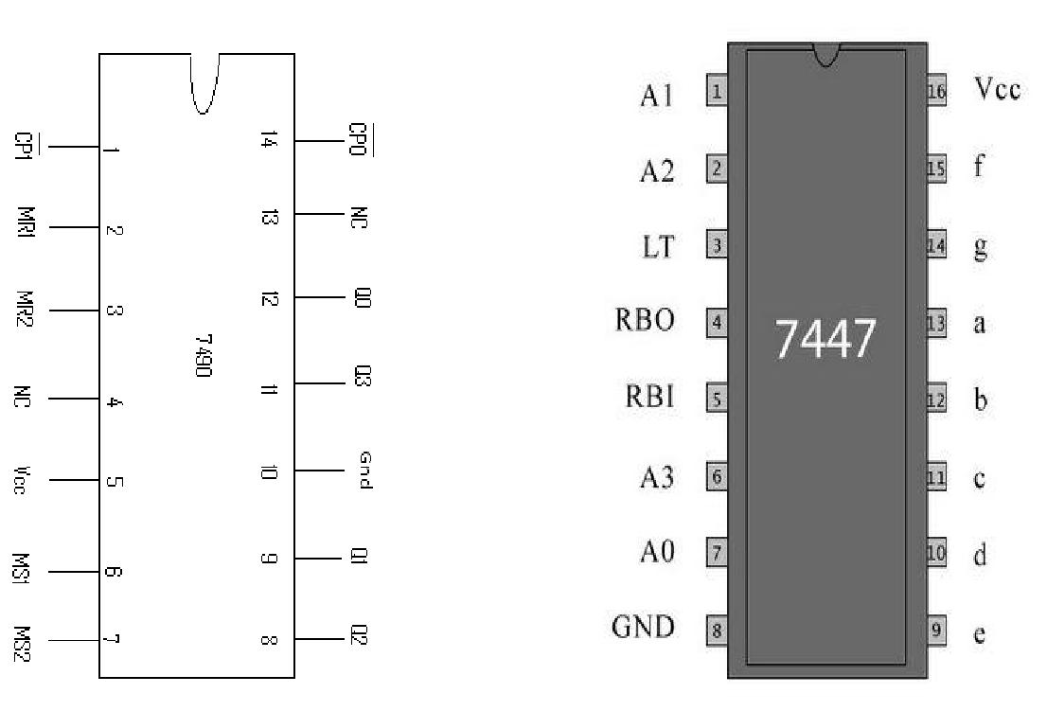

Pin Names Description of 7447:
A0–A3 =BCD Inputs

RBI =Ripple Blanking Input (Active LOW) LT= Lamp Test Input (Active LOW)

RBO =Ripple Blanking Output (Active LOW) a –g =Segment Outputs (Active LOW)

Pin Names Description of 7490:

R1 and R2-clear all filpflop (high active and low for not active) S1 and S2- set all flip flop (high active and low for not active) CLK_{A}-clock pulse to first flip flop
CLK_{B}-clock pulse to second flip flop (output of first flip flop clock for second filp flop)
Circuit Diagram:
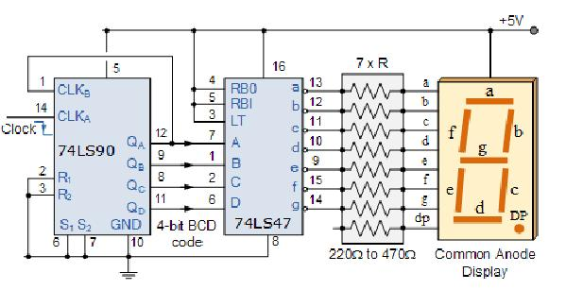

For mod 9

connect Q0 and Q3 to reset(clear) through an AND gate. Reset should not be connected to the switch

For mod8
Connect Q3 to reset

For mod7
Connect Q2, Q1,Q0 to reset through an And Gate

For Mod 6
Connect Q2 and Q1 to reset through an AND gate

For mod 5
Connect Q0 and Q2 to reset through an AND gate

For Mod 4
Connect Q2 to reset

For mod 3
Connect Q1 and Q0 to reset through an AND gate

For mod 2
Connect Q1 to reset

Function Table:

 | Clock |  | Q3 | Q2 | Q1 | Q0
 | 0 |  | 0 | 0 | 0 | 0
 | 1 |  | 0 | 0 | 0 | 1
 | 2 |  | 0 | 0 | 1 | 0
 | 3 |  | 0 | 0 | 1 | 1
 | 4 |  | 0 | 1 | 0 | 0
 | 5 |  | 0 | 1 | 0 | 1
 | 6 |  | 0 | 1 | 1 | 0
 | 7 |  | 0 | 1 | 1 | 1
 | 8 |  | 1 | 0 | 0 | 0
 | 9 |  | 1 | 0 | 0 | 1

